System Architecture of Linux
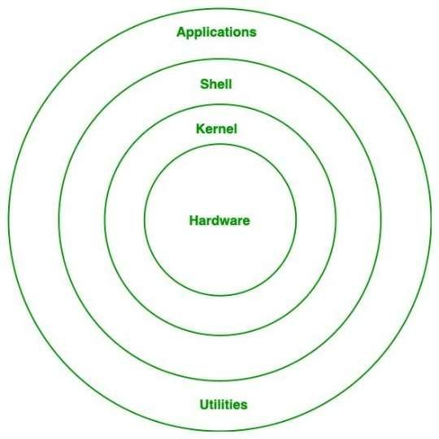
Hardware Layer: This layer consists all peripheral devices like RAM/ HDD/ CPU etc.
Kernel: Kernel is the core of the Linux based operating system. It virtualizes the common hardware resources of the computer to provide each process with its virtual resources. .

Shell: It is an interface to the kernel which hides the complexity of the kernel’s functions from the users. It takes commands from the user and executes the kernel’s functions.
Application: It provides the functionalities of an operating system to the user.

1)Access The Command Line

1. pwd (Print Working Directory)

Meaning
Shows your current location (folder) in Linux.

Example
pwd

Output
/home/user
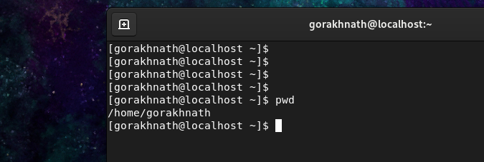

2. ls (List files)

Meaning
Shows files and folders in the current directory.

Example
ls

Output
Desktop Documents Downloads
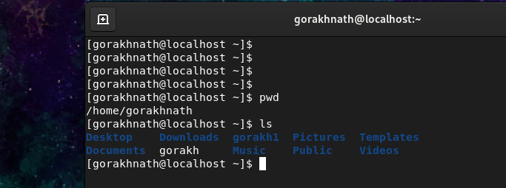

3. cd (Change Directory)

Meaning
Used to move into a folder.

Example
cd Documents
Moves into Documents folder


4. cd .. (Go back one folder)

Meaning
Moves one level up.

Example
cd ..


5. cd / (Go to root directory)

Meaning
Moves to the main root folder of Linux system.

Example
cd /
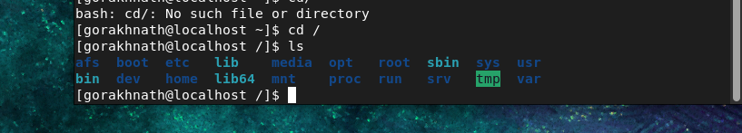

6. date

Meaning
Shows current system date and time.

Example
date

Output
Wed Dec 14 02:10:18 AM IST 2022
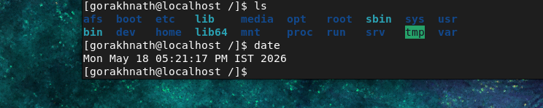

Date formatting examples (like in your image)

date +%R # Time (HH:MM)
date +%r # Full time with AM/PM
date +%x # Date format
date +%d # Day of month
date +%m # Month
date +%y # Year (last 2 digits)

7. whoami

Meaning
Shows current logged-in user.

Example
whoami

Output
Root
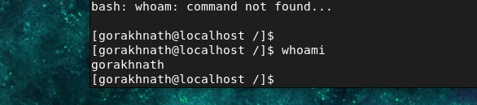

8. cal (Calendar)

Meaning
Shows calendar.

Example
Cal
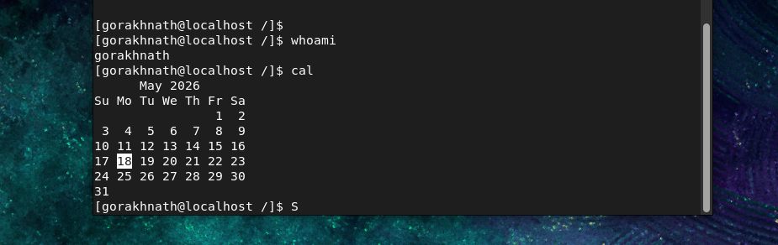

9. df -h (Disk Free)
⚠️ Your command df-u is incorrect. Correct is:
df -h

Meaning
Shows disk usage in human-readable format.

Example Output
Filesystem Size Used Avail
/dev/sda1 20G 10G 10G
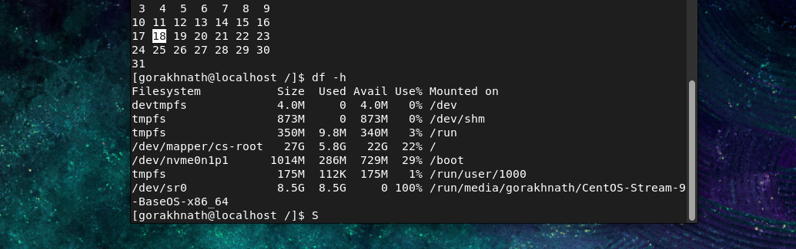

10. bc (Calculator)

Meaning
Used for math calculations in terminal.

Example
bc
2+3

Output
5
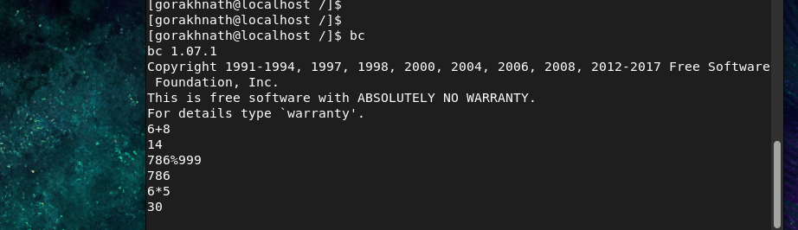

11. id

Meaning
Shows user ID and group ID.

Example
id

Output
uid=0(root) gid=0(root)


12. history
⚠️ You wrote hostory (wrong spelling)

Meaning
Shows previously used commands.

Example
History
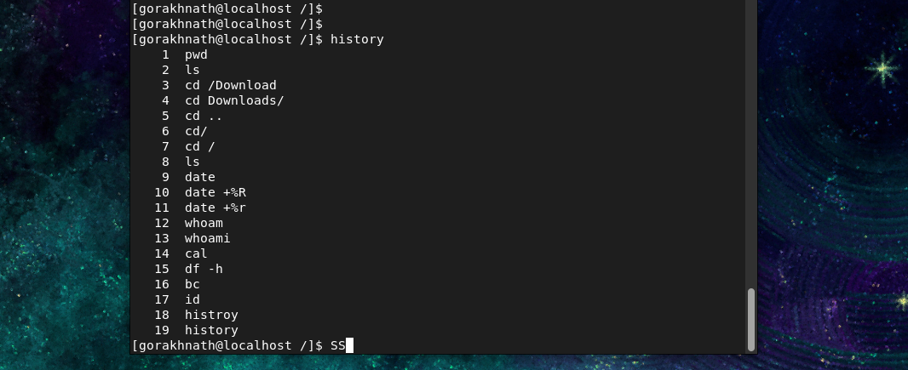

13. su (Switch User)

Meaning
Used to switch to another user (often root).

Example
su root
Asks for password and switches user


14. Check current hostname
hostname
or
hostnamectl
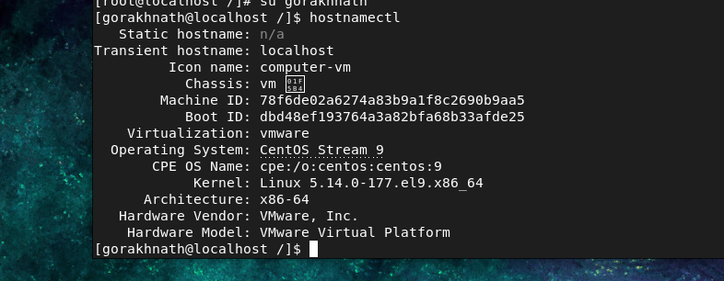

15. Change hostname (temporary method)
⚠ This change will reset after reboot.
hostname new-name

Example
hostname myserver

16. Change hostname permanently (recommended)

Step 1: Use hostnamectl
sudo hostnamectl set-hostname new-name

Example
sudo hostnamectl set-hostname gorakh
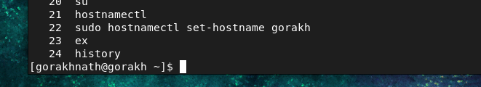

2) Manage Files From the Command Line (Bash Shell)
In Linux (CentOS), we use commands to create, copy, move, rename, and delete files and directories.

1. mkdir — Create Directory

Meaning
Used to create new folders (directories).

Create one directory
mkdir folder1

Create multiple directories
mkdir folder1 folder2 folder3

Create a series of directories
mkdir harry{1..10}
Creates: harry1, harry2, ..., harry10
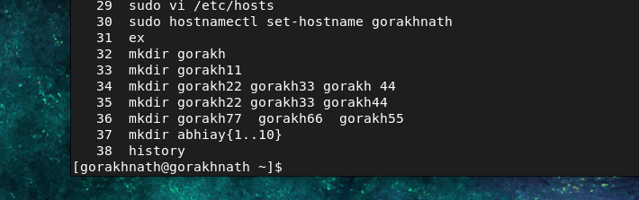

Create parent directories (-p option)
mkdir -vp red/hat/docs
Creates full path even if parent folders don’t exist
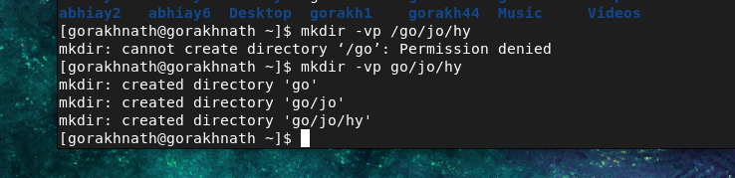

2. rmdir — Remove Directory

Meaning
Used to delete empty directories.

Remove one directory
rmdir folder1

Remove multiple directories
rmdir folder1 folder2 folder3

Remove series of directories
rmdir harry{1..10}

Remove parent directories
rmdir -vp red/hat/docs
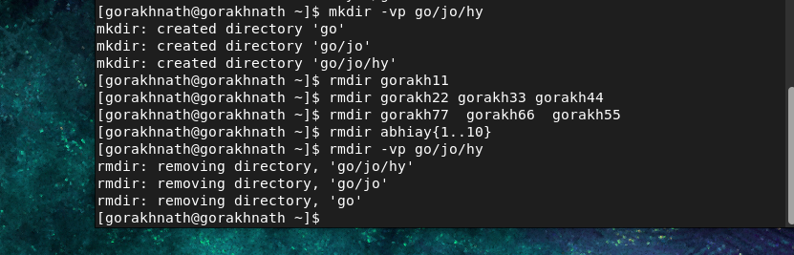

3. touch — Create Files

Meaning
Used to create empty files.

Create one file
touch file1

Create multiple files
touch file1 file2 file3

Create series of files
touch file2{1..10}
👉 Creates file1 to file100
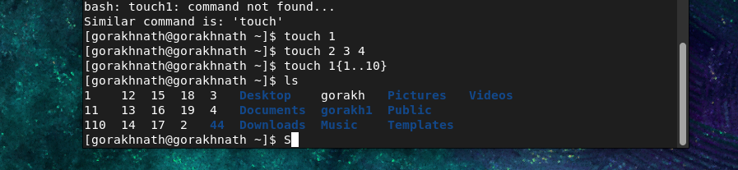

4. rm — Remove Files

Meaning
Used to delete files permanently.

Remove one file
rm file1

Remove multiple files
rm file1 file2 file3 file4

Remove series of files
rm file{1..100}
⚠️ Be careful: deleted files cannot be recovered easily.
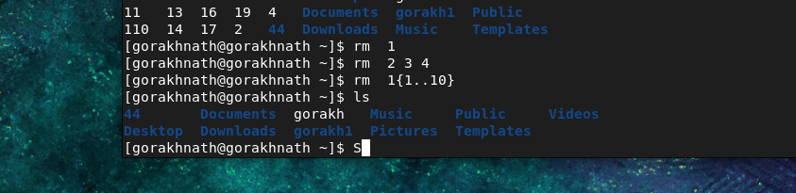

5. cp — Copy Files or Directories

Meaning
Used to copy files from one location to another.

Example
cp file1 folder1
👉 Copies file1 into folder1
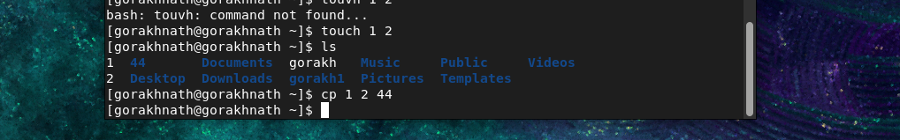
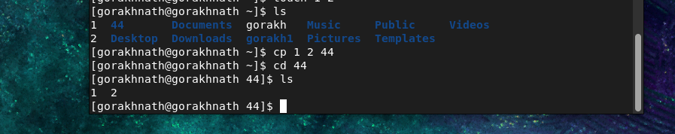

Copy multiple files (example)
cp file1 file2 folder1

6. mv — Move Files or Rename Files

Meaning
Used for moving or renaming files/folders.

Move file to another folder
mv file1 folder1

Rename file
mv file1 file2
file1 becomes file2
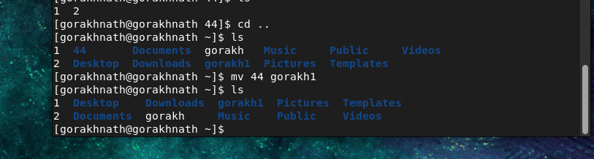
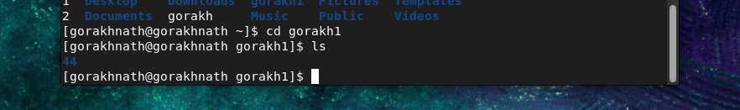

7) how to create file inside folder:-
If you already created a folder named 3, you can create a file inside it like this:
touch 3/app.log

Use tree command to see recursive files.

8) echo:-
echo is a command used to print text to the terminal or write text into a file.

Overwrite file content
echo "Application started" > folder1/app.log
- > writes text into the file
- If the file already has content, it replaces it

Append text without removing old content
echo "New log entry" >> app.log
- >> adds text to the end of the file

